Software Requirements Specification

for

SA Hub: Enhancing APC-SA Process Through Automated Record Keeping and Criteria-Based Task Assignment Web-Based System

Version 1

Prepared by

Group Name: DIVAlopers

|  |  |  |
| --- | --- | --- |
| Nathan Rameses L. Balois  John Michael D. Gonzales | 2021-140005  <student #> | nlbalois@student.apc.edu.ph  jdgonzales2@student.apc.edu.ph |
| Sayaka Aliyah P. Hernandez | 2021-140010 | sphernandez@student.apc.edu.ph |
| Priam Japheth G. Jauod | 2021-140009 | pgjauod@student.apc.edu.ph |
| Gianna Cristina S. Reyes | 2021-140011 | gsreyes4@student.apc.edu.ph |
| Alelie Yvonne S. Tayco | 2021-140008 | astayco@student.apc.edu.ph |

Contents

Contents ii

Revisions iii

1 Introduction 1

1.1 Document Purpose 1

1.2 Product Scope 1

1.3 Intended Audience and Document Overview 2

1.4 Definitions, Acronyms and Abbreviations 2

1.5 Document Conventions 3

1.6 References and Acknowledgments 4

2 Overall Description 6

2.1 Product Overview 6

2.2 Product Functionality 8

2.3 Design and Implementation Constraints 9

2.4 Assumptions and Dependencies 11

3 Specific Requirements 13

3.1 External Interface Requirements 13

3.2 Functional Requirements 17

3.3 Use Case Model 20

4 Other Non-functional Requirements 30

4.1 Performance Requirements 30

4.2 Safety and Security Requirements 31

4.3 Software Quality Attributes 31

5 Other Requirements 34

Appendix A – Data Dictionary/ERD 34

Appendix B - Group Log 39

Appendix C – Test Plan/Test Cases 41

|  |  |
| --- | --- |
| Instructor: | Manuel Sebastian S. Sanchez |
| Course: | SOFTDEV |
| Date: | September 9, 2024 |

Revisions

| Version | Primary Author(s) | Description of Version | Date Completed |
| --- | --- | --- | --- |
| 1 | Full Name | Information about the revision. This table does not need to be filled in whenever a document is touched; it only needs to be filled in when the version is being upgraded. | 00/00/00 |

# 

# Introduction

This document outlines the objectives and framework of SA Hub, providing a comprehensive overview of its scope and intended audience. It aims to inform stakeholders, including team members and project sponsors, about the project's goals and deliverables. Additionally, the document defines key terms, acronyms, and abbreviations to ensure clarity and understanding throughout. Established conventions for formatting and terminology are employed to maintain consistency. Lastly, references to relevant materials and acknowledgments to contributors are included to enhance the document's credibility and support the project's successful execution.

## Document Purpose

This document outlines the software requirements for the SA Hub system, designed to automate and optimize the Student Assistants (SA) task assignment process at Asia Pacific College (APC). The software version covered in this document is the system's initial release, focusing on automating record-keeping and criteria-based task allocation for Student Assistants. This Software Requirements Specification (SRS) aims to provide a clear and comprehensive guide to all functionalities, features, and constraints of the system, ensuring that the development, testing, and implementation phases align with user needs and institutional requirements.

## Product Scope

The SA Hub system aims to smoothen the manual processes of assigning tasks to APC Student Assistants. Its main goal is to provide automated record-keeping of rendered hours and allocate tasks based on the availability and course programs of SAs. This will significantly reduce manual errors, improve time management for SAs, and increase the efficiency of task assignments. By automating these processes, the system ensures that students have relevant job experiences and that offices receive prompt and accurate assistance. Key benefits include reducing workload for the Student Assistant Manager, increasing job satisfaction for SAs, and improving the quality of office task assignments.

## Intended Audience and Document Overview

This SRS is intended for the following audiences: developers responsible for building the system, project managers overseeing the development, testers validating functionalities, student assistants, APC staff (including the SA Manager and Office personnel) who will use the system, and the professor reviewing the project. The document provides a structured breakdown of the system’s functionalities, beginning with an introduction to the system and its goals, then detailed descriptions of functional and non-functional requirements, and concluding with models and diagrams guiding system implementation. Readers should start with the overview sections and move through the functional requirements to understand the core system capabilities, followed by technical diagrams for development and testing teams.

## Definitions, Acronyms and Abbreviations

This section provides a list of all abbreviations and acronyms used in this document to ensure consistent interpretation of terms.

|  |  |  |
| --- | --- | --- |
| Abbreviations | Acronyms | Definitions |
| APC | Asia Pacific College | A private higher education institution in the Philippines focusing on technology and business. |
| DO | Discipline Office | Office in APC responsible for enforcing academic policies and discipline. |
| ERD | Entity Relationship Diagram | Visual representation of the entities in a database and their relationships. |
| GWA | General Weighted Average | Numerical representation of a student's academic performance, calculated by averaging grades, weighted by credit units. |
| TMS | Microsoft | Multinational technology company known for its software products, including Windows OS and Microsoft Office. |
| SA | Student Assistant | Student employed to assist faculty or staff with various academic or administrative tasks. |
| SAP | Student Assistant Program | The program is designed to provide students with opportunities to work as assistants in various capacities within an educational institution. |
| UI/UX | User Interface/ User Experience | UI refers to the design of user interfaces, while UX focuses on users' overall experience when interacting with a product or service. |

## Document Conventions

This document follows the IEEE formatting requirements. The conventions are outlined below:

* **Font**: Use **Arial** font, size **11**,throughout the document for all text.
* **Italics**: Use *italics* for comments and notes for a clear distinction.
* **Text Spacing**: The document is **double-spaced** to enhance readability.
* **Margins**: Maintain **1-inch margins** on all sides as this template specifies.
* **Section Titles**: Follow the template for formatting section and subsection titles, ensuring they are bold and appropriately sized for clear navigation.

**Naming Conventions**

* Variables and system components should be named consistently with standard programming conventions, using descriptive names wherever possible (e.g., student_schedules, sa_profiles).

## References and Acknowledgments

When creating software requirements specifications, it's essential to acknowledge the tools and resources that inform your process. In this regard, ChatGPT, developed by OpenAI, offers valuable insights through its natural language processing capabilities, enabling clear communication of complex requirements. Additionally, Visual Paradigm is a powerful modeling tool, facilitating the visualization and documentation of software requirements. APC Student Handbook for providing details on SAP and related regulations.

Together, these resources enhance the clarity, accuracy, and effectiveness of requirements gathering and specification, ensuring that all stakeholders understand the project goals.

# Overall Description

## Product Overview

### Product Overview

**Product Perspective:**

Student Assistant (SA) task assignment process and integrating scholarship status management at Asia Pacific College (APC). In addition to automating task allocation and record-keeping, the system introduces a robust scholarship management feature, ensuring comprehensive oversight of SAs' academic and work performance.

The system is designed to support three primary stakeholders: Student Assistants, the SA Manager, and the Guidance Office. The SA Manager oversees task assignments and manages scholarship statuses, monitoring SAs on probation or those whose scholarships have been canceled. The Guidance Office and SA Manager are provided with a dashboard to review scholarship reports at the end of each academic year, streamlining administrative processes and ensuring transparency across departments.

**Diagram Description:**

At a high level, the system will interact with three major stakeholders: SAs, the Student Assistant Manager (SA Manager), and Requesting Offices. The interaction includes submitting task requests, assigning SAs to tasks based on their schedules and program requirements, and generating reports on task completion.

Figure 1. Context Flow Diagram

In this diagram:

* Requesting Offices submit tasks via the system.
* The SA Hub automates task assignments based on criteria such as availability and academic program.
* The SA Manager supervises tasks and manages SA scholarship statuses.
* The Guidance Office uses the scholarship dashboard to monitor reports on SAs, including their scholarship status (scholar, probation, or cancelled) and reasons for probation or cancellation.

## Product Functionality

**Major Functions of the System:**

* Automated Task and Voluntary Assignment: Tasks are assigned to Student Assistants based on their academic program and availability.
* Real-time Task Tracking: The system allows tracking of task progress and deadlines.
* Profile and Attendance Management: Student Assistants manage profiles, log work hours, and view task history.
* Criteria-based and Voluntary Task Requests: Offices can submit specific requests or post voluntary tasks.
* Scholarship Status Management: The system manages and tracks scholarship statuses, including scholarship, probation, and cancellation details.
* Cancellation of Scholarship: Displays a table with the SA’s name, reason for cancellation, and a cancellation button.
* Notify SA Scholarship Revocation: Offices will be notified when SA/s assigned to their task is/are removed due to scholarship revocation.
* Dashboard for Scholarship Management: The system provides a dedicated dashboard to monitor the number of SAs and their scholarship statuses (scholar, under probation, or cancelled) at the end of each academic year. It also tracks reasons for probation and cancellations.
* Report Generation: Generates comprehensive reports, including task completion, rendered hours, and scholarship status updates.

## Design and Implementation Constraints

**Hardware Limitations**

The system must respond to user input and process tasks within acceptable timeframes, especially for time-sensitive tasks. The system should be efficient in its use of memory to avoid performance bottlenecks and ensure smooth operation.

**Interfaces with Other Applications**

The system may need to integrate with existing systems like a student information system or HR system, requiring compatibility and data exchange protocols.

**Specific Technologies, Tools, and Databases**

Factors like team expertise, project requirements, and long-term maintainability will influence the choice of programming languages, frameworks, and databases. The database should be capable of handling the expected data volume, providing efficient query performance, and supporting the required data structures and relationships.

**Language Requirements**

The chosen language should be suitable for web development, have a strong community and ecosystem, and offer the necessary features for the project. Appropriate network protocols (e.g., HTTP, WebSocket) should be selected if the system involves communication with other systems or devices.

**Security Considerations**

The system must protect sensitive data like SA information and task details from unauthorized access. Also, robust user authentication and authorization mechanisms should be implemented to control access to different system features.

**Design Conventions or Programming Standards**

Adhere to coding standards and conventions to ensure code readability, maintainability, and consistency. The team should also consider using established design patterns to improve code structure, reusability, and extensibility.

**Additional Constraints**

The project may have budgetary constraints that limit the scope of features or the choice of technologies. It may be subject to tight deadlines, which could impact the level of detail in design or the implementation approach.

By carefully considering these constraints, the development team can make informed decisions and create a system that meets the project's objectives while addressing potential challenges.

## Assumptions and Dependencies

The successful implementation of the web-based task assignment system hinges on several key assumptions. These assumptions encompass factors related to third-party components, development and operating environments, constraints, and dependencies on external factors. If any of these assumptions prove incorrect or changed, it could significantly impact the project's requirements, design, and implementation. Therefore, it is essential to carefully consider and validate these assumptions early in the development process to mitigate potential risks and ensure the system's effectiveness.

**List of Assumptions Related to Third-Party Components**

* Integration with Existing Systems: Assuming seamless integration with existing HR systems, learning management systems, or other relevant software. This includes factors such as compatibility of data formats, APIs, and security protocols.
* Reliability of Time Tracking Software: Assuming the accuracy and reliability of any third-party time tracking software used. This may involve data privacy, security, and the software's ability to handle large volumes of data.

**Assumptions Regarding Development and Operating Environment**

* Internet Connectivity: Assuming consistent and reliable internet connectivity for all users. This includes network infrastructure, bandwidth, and potential disruptions due to outages or maintenance.
* Hardware and Software Requirements: Assuming sufficient hardware resources (e.g., servers, storage) and compatible software (e.g., operating systems, databases). This may involve scalability, performance optimization, and compatibility with other systems.
* Security Measures: Assuming adequate security measures can be implemented to protect sensitive data. This includes data encryption, access controls, and protection against cyber threats like hacking and data breaches.

**Assumptions Related to Constraints**

* Budget: Assuming sufficient budget to cover development, maintenance, and ongoing costs. This may involve cost-benefit analysis, resource allocation, and potential cost overruns.
* Timeline: Assuming the three-month timeline is feasible and can accommodate unforeseen challenges. This may involve project management methodologies, resource allocation, and risk management strategies.
* User Adoption: Assuming users will readily adopt the new system and provide necessary feedback for improvements. This may involve user training, change management, and ongoing support.

**Dependencies on External Factors**

* User Acceptance: The system's success may depend on user acceptance and adoption, which can be influenced by factors such as training, support, and perceived benefits.
* Academic Calendar Changes: Changes to the academic calendar, such as unexpected breaks or modifications to class schedules, could affect the system's ability to accurately schedule tasks.
* Ethical Considerations: Ethical considerations, such as data privacy and fairness in task allocation, may need to be addressed in the system's design and implementation.

# Specific Requirements

## External Interface Requirements

### User Interfaces

1. Student Assistant Perspective

1. Homepage – Displays the features with a brief description for the student assistant and a menu bar that can be found on all web pages. The user can see the tasks assigned automatically by the system based on their vacant schedule or course program. The SA or SAs, depending on the number of SAs needed that fit the criteria, can only receive that task. The table shows the date, time, course program, office name, and office note. SAs can accept voluntary tasks and time on and off this page.

1. Profile – The SA can view their name, year level, course program, and class schedule connected to the APC database
2. Student Assistant Manager Perspective

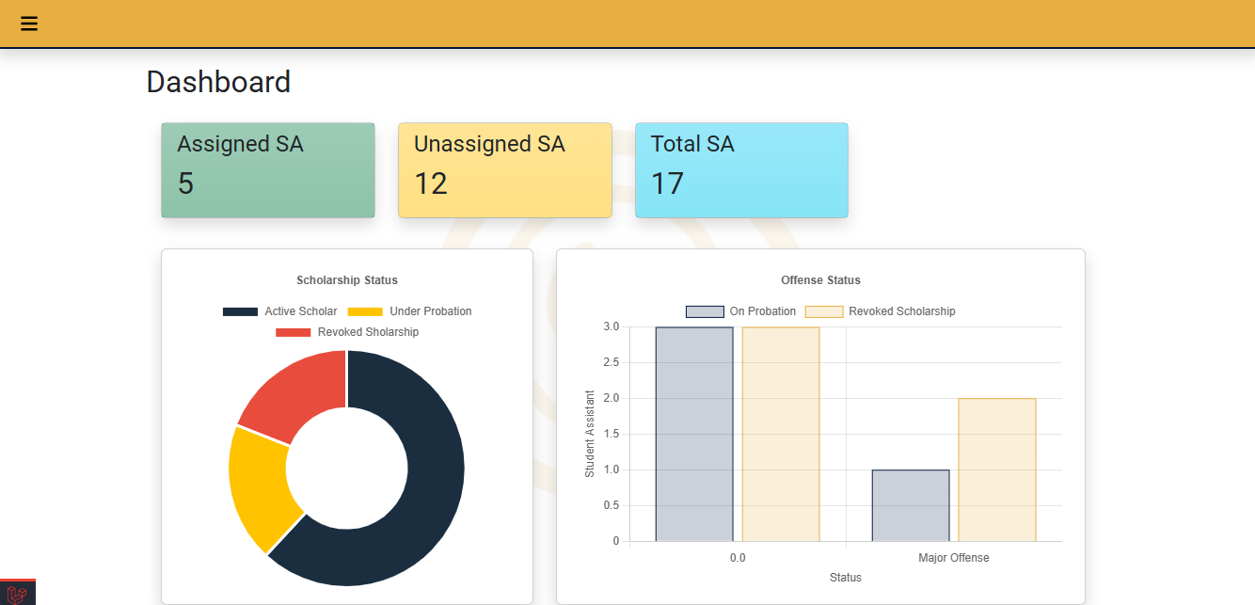

* 1. Homepage – On this page, the discipline head can view tasks and assignments from the offices. This will now be automatically accessible to student assistants who meet the criteria (vacant time from the class schedule and/or course program). The tasks are also categorized into two statuses: ongoing and done.

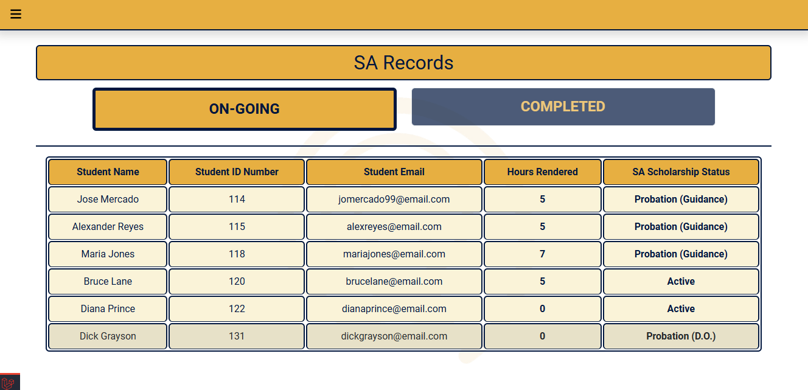

* 1. Student Assistant Records – This page contains details of student assistants, such as name, student ID, email address to contact them for a certain reason, and total hours rendered. For a more organized look and easy monitoring, the user can either choose to see complete and ongoing student assistants.

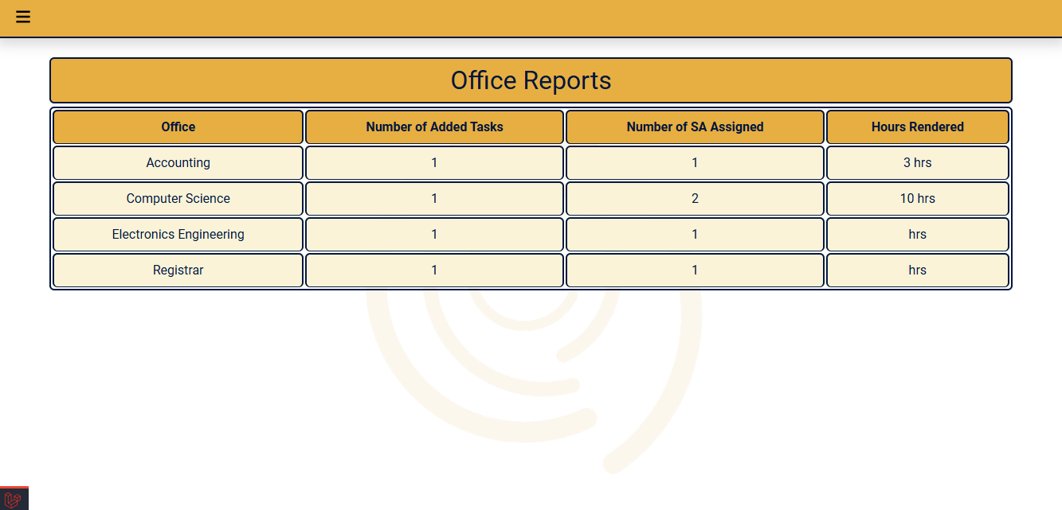

* 1. Office Reports – This is where the DO can monitor the office’s task assignments. Total number of added tasks, SAs assigned, and hours assigned.

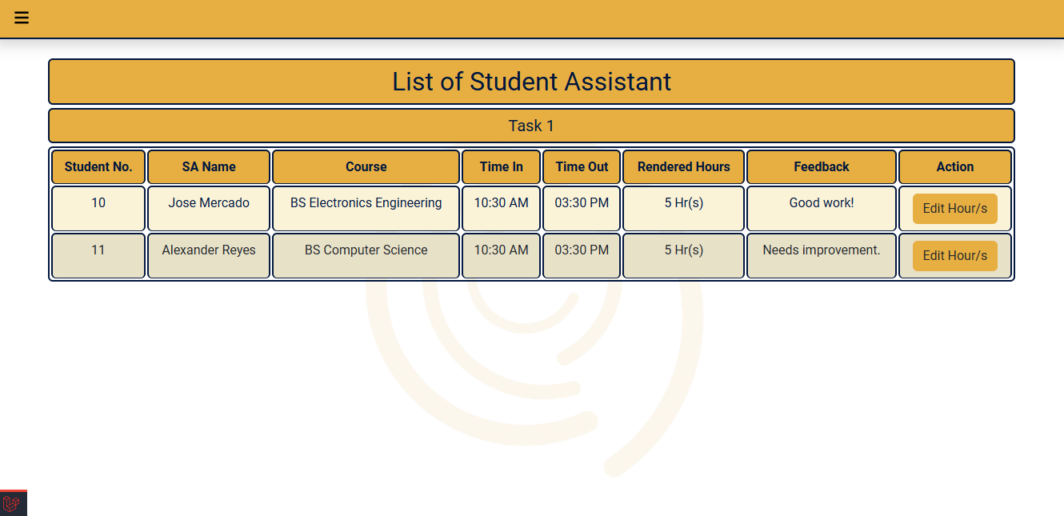

* 1. Review Feedback – The SA Manager can view the SA assigned to that task. After viewing, the name, total hours rendered, and feedback from the office are displayed. The SA manager can view SAs per task to see office feedback, their time in and out, and edit hours for merits.

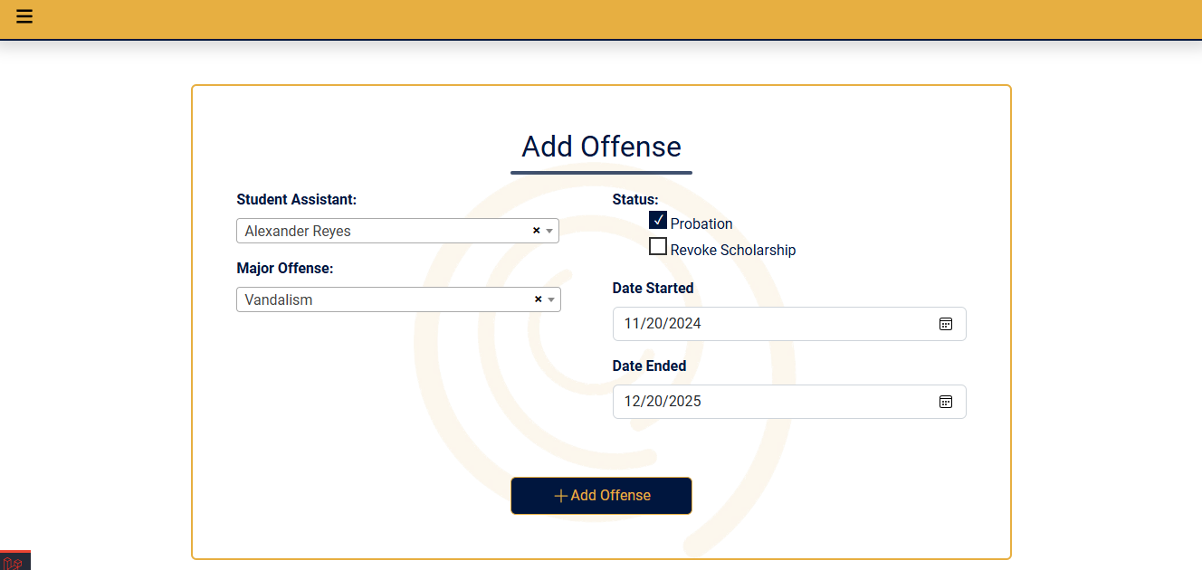

* 1. Add Major Offense – The SA Manager, also known as the Discipline Officer, can add major offenses of SAs to be recorded on the system, which will also be used as a criterion for evaluating the scholarship status of SA. SA Manager can enter the type of major offense, status, and reasons.

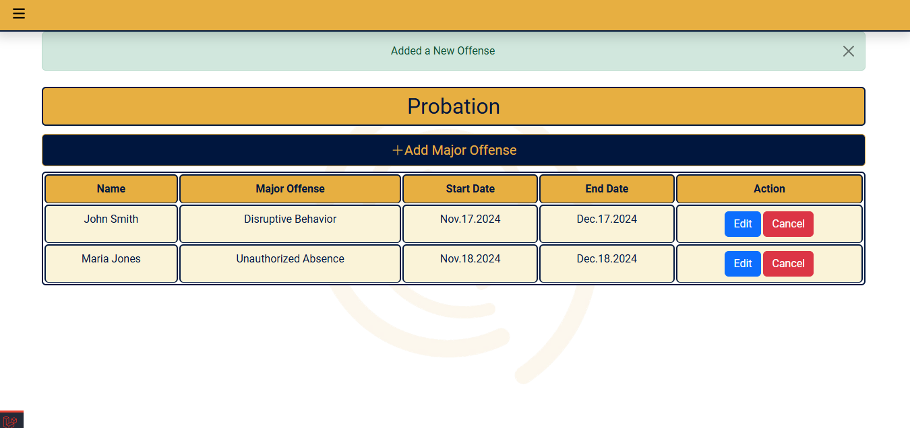

* 1. Probation Page - The table lists SAs under probation for major offenses.

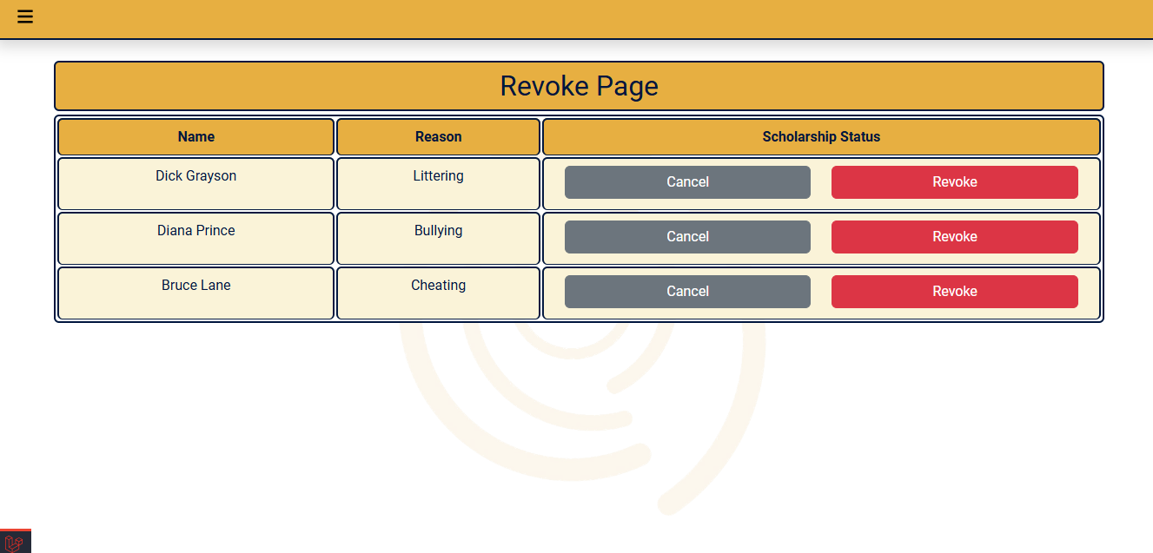

* 1. Scholarship Page - The table shows a list of SAs with buttons on the sides where the SA Manager can input his/her verdict regarding SA’s scholarship status.

1. Office Perspective

1. Homepage – This page allows the office to add tasks and view their assignments. When adding a task, the user will fill out the form (Required: date and time, number of student assistants, and note. Optional: course program, tasks to be done, and voluntary task option). They can also edit and cancel the task.

1. Notifications – Offices will be notified when SA assigned to their tasks
2. Guidance Office

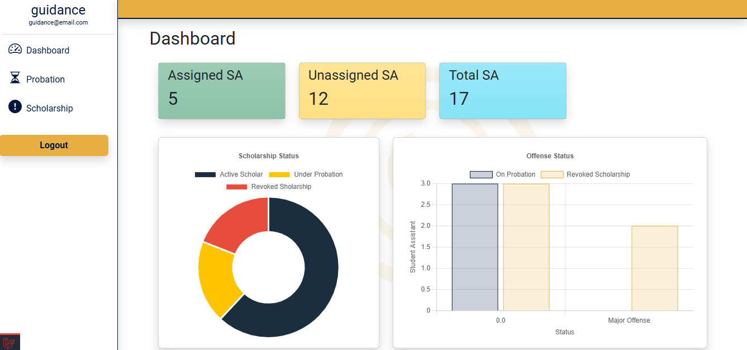

1. Home Page/Dashboard - This page shows graphs to illustrate data for the number of SAs, scholarship status reports at the end of the school year (scholar, under probation, cancelled), the reason for probation, and the reason for cancellation.

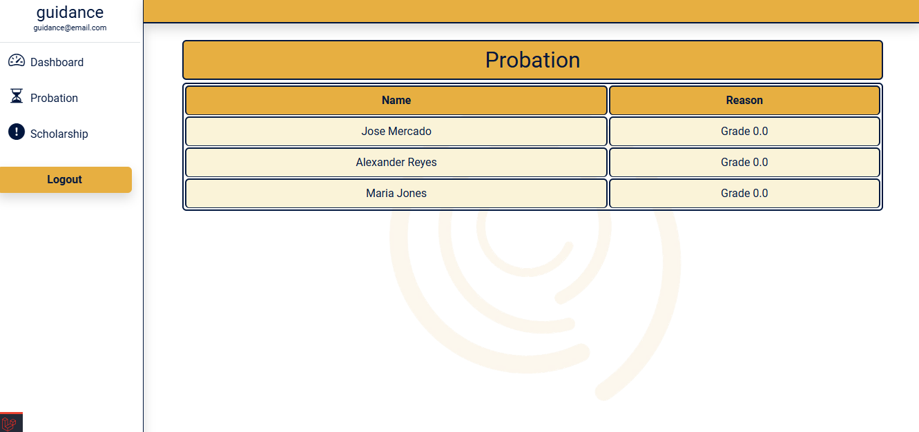

1. Probation Page – A table that shows SA under probation. If the SA has 0.0 or FAIL at the end of the school year, his/her name will be reflected in this table.

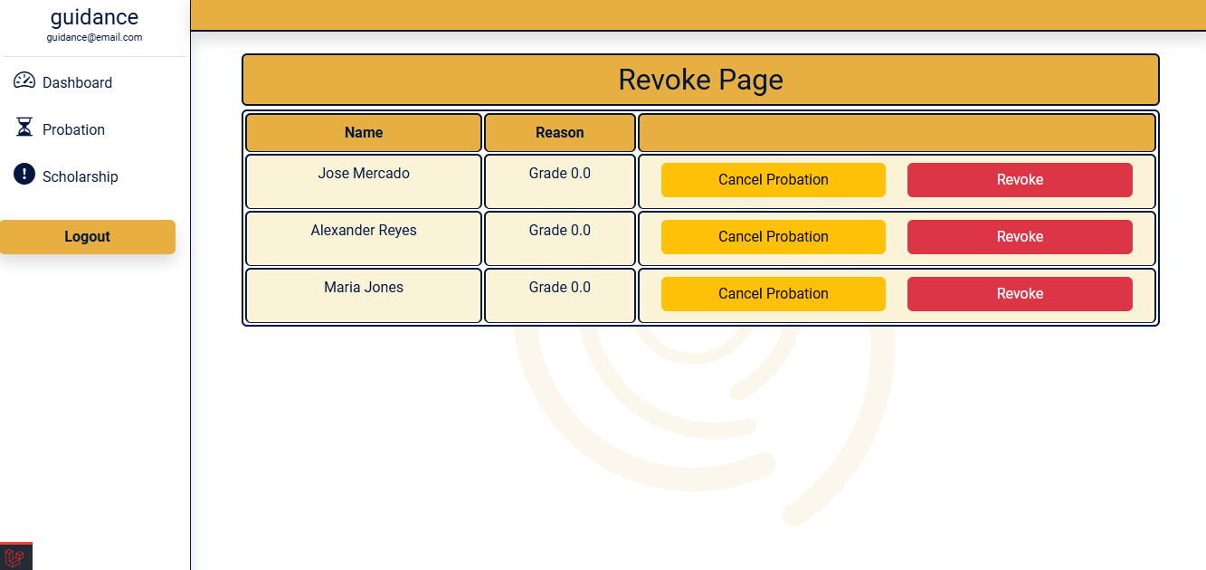\

1. Scholarship Page - A table that shows SAs under cancellation of scholarship. If the SA is under probation and another 0.0 or FAIL at the end of the school year, his/her name will be reflected in this table. There are buttons on the sides where the Guidance Office can input his/her verdict regarding SA’s scholarship status.

### Hardware Interfaces

The system's interactions with hardware components primarily involve standard input and output devices, such as keyboards, mice, monitors, and printers. These devices will facilitate user interaction, data entry, and information display. While the system may not require direct interaction with sensors or specialized hardware, integrating such devices in the future should be considered.

**Input Devices**

Keyboard: For manual data entry (e.g., task descriptions, SA names).

Mouse: For navigation and interaction with the user interface (on desktop and laptop devices).

Touchscreen: For navigation and interaction with the user interface on smartphones and tablets.

**Output Devices**

Monitor: This displays information, such as task lists and SA schedules.

Screen: For displaying information on smartphones and tablets.

**Supported Devices**

Desktop Computers: These are for users who need a larger screen and more powerful hardware.

Laptops: For users who require portability and flexibility.

Smartphones: For users who prefer mobile access and convenience.

Tablets: These are for users who desire a screen larger than a smartphone but still want portability.

### Software Interfaces

The task assignment system will interact with various software components to facilitate data exchange and functionality. Key connections include integration with the student portal for accessing student information and course data and integration with reporting and analytics tools for data analysis and visualization. These connections will enable the system to effectively manage task assignments, track student progress, and provide valuable insights into the overall performance of the task assignment process.

**Student Portal and Information**

* Student Information: The system may need to access student information, such as class schedules, program, and contact details, from the LMS.
* Course Data: Integration with the LMS can provide information about available courses, prerequisites, and course requirements, which can be used to assign tasks relevant to students' academic progress.

**Reporting and Analytics Tools**

* Data Export: The system may need to export data to reporting and analytics tools for further analysis and visualization.
* Integration: Integration with reporting tools can provide insights into task assignment efficiency, SA performance, and workload distribution.

## Functional Requirements

### F1: Automated and Voluntary Task Assignment

* FR1: The system shall automatically assign tasks to SAs based on their class schedule and course.
* FR2: The system should assign voluntary task to all SAs.
* FR3: The system shall retrieve and use SAs' profiles, records, and availability schedules to match task requirements.
* FR4: The system shall update task assignments in real-time and update the related pages of the assigned SAs.

### F2: Real-time Task Tracking

* FR1: The system shall display real-time task status updates for each assigned task.
* FR2: The system shall allow users to view and update the progress of tasks.

### F3: Profile and Attendance Management

* FR1: The system shall enable SAs to time in/out to log their work hours.
* FR2: The system shall provide a view of the task history for each SA.

### F4: Criteria-based and Voluntary Task Requests

* FR1: The system shall allow offices to submit task requests based on specific criteria or task types.
* FR2: The system shall display automatically assigned tasks and do the posting of voluntary tasks for SAs to accept.

### F5: Scholarship Status Management

* FR1: The system shall track and update scholarship statuses, including Scholar, Under Probation, and Scholarship Revoked.
* FR2: The system shall maintain records of reasons for probation or scholarship revocation.
* FR2: The system shall allow the SA Manager and the Guidance Office to specify probation or scholarship cancellation reasons.
* FR3: The system shall display the updated scholarship details on any pages related to scholarship status.

### F8: Cancellation of Scholarship Page (SA Manager account)

* FR1: The system shall display a table with the names and relevant information of SAs whose scholarships are flagged because of major offenses.
* FR2: The system shall include a reason for each cancellation in the displayed table.

### F9: Guidance Dashboard for Scholarship Management

* FR1: The system shall provide a dedicated dashboard for monitoring the number of SAs and their scholarship statuses.
* FR2: The system shall display scholarship statuses (Scholar, Under Probation, Scholarship Revoked) at the end of each academic year.
* FR3: The system shall track and display reasons for probation and scholarship revocation on the dashboard.

### F10: Cancellation of Scholarship Page (Guidance Office account)

* FR1: The system shall display a table with the names and relevant information of SAs whose scholarships are automatically flagged as under probation because of academic performance.
* FR2: The system shall provide action buttons for processing scholarship status, whether to Cancel Probation, Revoke Scholarship, or Retract Cancellation of Scholarship for isolated cases.
* FR3: The system shall include reasons for each action button clicked in the displayed table.

### F11: Report Generation

* FR1: The system shall generate comprehensive reports on task completion, rendered hours, and scholarship status updates.

~~.~~

## Use Case Model

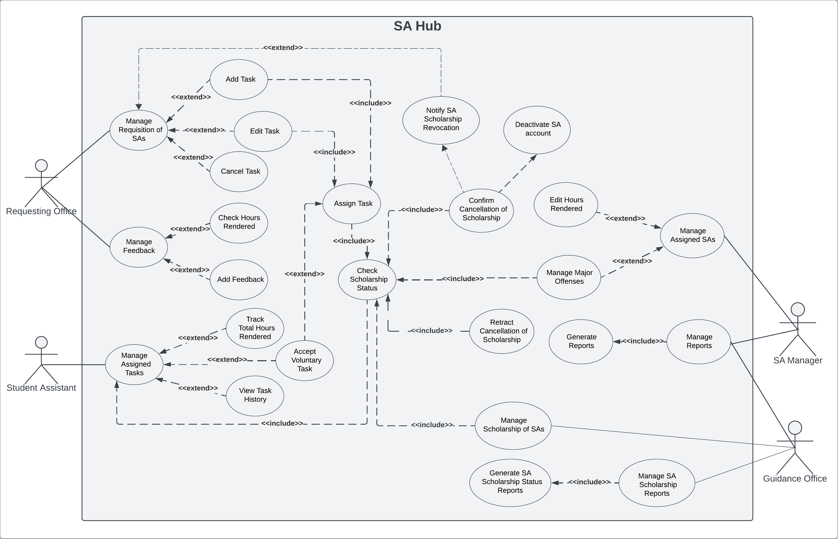

Figure 2. Use Case Diagram

### Use Case #1

|  |  |  |
| --- | --- | --- |
| **Use Case ID:** | **UC1** | |
| **Use Case Name:** | **Manage Requisition of SAs** | |
| **Scenario:** | The requesting office needs SAs to do a certain task | |
| **Triggering Event:** | Requisition for SAs | |
| **Brief Description:** | This use case allows the requesting office to add tasks to request SAs and receive notifications on assigned SA’s scholarship revocation. Also, the requesting office can edit or cancel the tasks created. | |
| **Actors:** | Requesting Office, SA Manager, Guidance Office | |
| **Related Use Cases:** | Add Task, Edit Task, Cancel Task, Notify SA Scholarhsip Revocation | |
| **Stakeholders:** | Asia Pacific College | |
| **Preconditions:** | * If the office is not logged in to their account, they cannot create tasks assigned to SAs. * There must be a task available * There must be an SA assigned to the task for notifications | |
| **Postconditions:** | * The system displays the Add Task form. * The system assigns the task. * The system deletes the task * Notifies office when assigned SA got their scholarship revoked | |
| **Flow of Activities:** | **Actor** | **System** |
| 1. The requesting office goes to its account homepage. 2. Manage Requisition for SA 2a. The Requesting Office creates a task for the SAs to do:   1. Clicks the Add Task button.  2. Fills out the Add Task form.  3. Submits the form.  2b. The Requesting Office wants to reschedule due to uncertain events (suspensions, changes in the decision, etc.):  1. The requesting office clicks the Edit button  2. Office edits task details.  3. Office clicks the submit button  2c. The Requesting Office wants to cancel the task due to uncertain events (suspensions, changes in the decision, etc.):  1. Office clicks the cancel button  3. SA Manager/Guidance SA revokes SA scholarship | 1.1. The system displays the requesting office account homepage.  2a.1.1 Displays the Add Task form.  2a.3.1 Proceeds to assign the created task to SAs.  2a.3.2 Post task to the assigned SAs, the SA Manager, and the Requesting Office  2b.1.1 Displays the Add Task form containing all the previous input  2b.3. Reassigns the task.  2c.1.1 Deletes the created task from all accounts.  3.1 Deactivates SA’s account  3.2 Notifies office about SA scholarhip revocation |
| **Exception Conditions:** | 2a.3. If the form to be submitted has incomplete required fields (date, time, no. of student assistant, task assignment type), then the system cannot process the form. 2b.3. If the edited task form has incomplete required fields (date, time, no. of student assistant, task assignment type), then the system cannot process the form.  2c. If the office cancelled a task, the SA who accepted or automatically assigned to the task will be reassigned to another task  3.2 If the SA got their scholarship revoked, only the office they are currently assigned to will receive a notification about their revocation which means they are also removed from the task. | |

### Use Case #2

|  |  |  |
| --- | --- | --- |
| **Use Case ID:** | **UC2** | |
| **Use Case Name:** | **Manage Assigned Tasks** | |
| **Scenario:** | Task Assignment | |
| **Triggering Event:** | SA is receiving an assigned task and tracking hours rendered. | |
| **Brief Description:** | This use case involves Student Assistants (SAs) accepting voluntary tasks and tracking the hours they have rendered for each task. | |
| **Actors:** | SA | |
| **Related Use Cases:** | Track Total Hours Rendered, Accept Voluntary Task, View Task History | |
| **Stakeholders:** | Asia Pacific College | |
| **Preconditions:** | * If the SA is not logged in to their account, they cannot view their task history and track their total hours rendered. * An assigned voluntary task is available in the system. | |
| **Postconditions:** | * The SA is assigned to a task or tasks. * The SA has accepted and commenced the voluntary task. * Hours rendered for the task are recorded. * SA Profile > Task History is updated. | |
| **Flow of Activities:** | **Actor** | **System** |
| 1. The SA logs into their account  2. Manages Assigned Task  2a. SA wants to do voluntary tasks.  1. Browse available voluntary tasks  2. Clicks accept task 2b. SA clicks time in 2c. SA clicks time out  2d. SA wants to check his/her total hours rendered.  1. SA goes to the homepage 2e. SA wants to see his/her task history  1. SA goes to profile. | 1.1 The system displays the SA account homepage.  2.1 Shows program-and-schedule-based assigned tasks and voluntary tasks.  2a.1.1 Display task details of voluntary tasks  2b.1 Record Time In  2c.1 Record time out  2d.1 Display total hours rendered.  2e.1 Display profile page. |
| **Exception Conditions:** | 2. If the SA does not do his/her assigned task, then the SA will be reassigned by the SA Manager to another task. | |

### Use Case #3

|  |  |  |
| --- | --- | --- |
| **Use Case ID:** | **UC3** | |
| **Use Case Name:** | **Manage Feedback** | |
| **Scenario:** | The requesting office wants to add feedback to SAs. | |
| **Triggering Event:** | Task Reviewing | |
| **Brief Description:** | This use case allows the requesting office to provide feedback to each SA assigned to their created task, validating the attendance and hours rendered by the SA. The SA Manager and the assigned SAs can also see the feedback on their respective accounts. | |
| **Actors:** | Requesting Office | |
| **Related Use Cases:** | Check Hours Rendered, Add Feedback | |
| **Stakeholders:** | Asia Pacific College | |
| **Preconditions:** | * If the office is not logged in to their account, they cannot review tasks and send feedback to SAs. * The task must be completed in terms of the specified start and end time | |
| **Postconditions:** | * The completed task is displayed on the Task Review page | |
| **Flow of Activities:** | **Actor** | **System** |
| 1. The requesting office goes to the Task Review page 2. Manages feedback.   2a. The requesting office views the hours rendered by the SA on the Task Review page containing task details (date, time, program, task, hours needed, note, assigned SAs with corresponding time in and time out, calculated hours based on time in/out)  2b. The requesting office wants to add feedback for SAs.  1. Clicks the Add Feedback button for each SA  2. Type the feedback on the text box form  3. Submit the feedback. | 1.1. The system displays the Task Review page containing the task details and the assigned SAs for each task.      2b.1.1. Displays the Feedback form containing the SA name and a text box.  2b.3.1. Processes the feedback form and reflects the feedback on the SA and the SA Manager accounts |
| **Exception Conditions:** | 2b. If the Requesting Office did not add feedback, no feedback will be reflected on SA and the SA Manager accounts | |

### Use Case #4

|  |  |  |
| --- | --- | --- |
| **Use Case ID:** | **UC4** | |
| **Use Case Name:** | **Manage Assigned SAs** | |
| **Scenario:** | Feedback Viewing and Major Offenses of SAs | |
| **Triggering Event:** | Feedback Submission and SAs’ Major Offenses | |
| **Brief Description:** | This use case involves the SA Manager reviewing, managing feedback submitted by Requesting offices for Student Assistants (SAs) after their assignments. It also includes adding and updating mojor offenses records of SAs. | |
| **Actors:** | SA Manager | |
| **Related Use Cases:** | Edit Hours Rendered, Add Major Offenses | |
| **Stakeholders:** | Asia Pacific College | |
| **Preconditions:** | * SAs have completed their assignments. * Feedback from SAs is available in the system | |
| **Postconditions:** | * Feedback is reviewed and managed by the SA Manager. * Major Offense record/s are reorded or updated * Appropriate actions are taken based on the feedback received | |
| **Flow of Activities:** | **Actor** | **System** |
| 1. The SA manager reviews the feedback to assess the performance of the SAs. 2. Takes appropriate actions based on the feedback and performance, including:   2a. SA has a merit.  1. SA Manager clicks edit hours    2. Input additional hours based on office feedback        3. Wants to add the major offense/s of the SA and clicks the Add Major Offense button  4. Fill out the Add Major Offense form and then submit  5. Edits major offense details | 1.1. Displays office feedback  2a.1.1 Show edit hours modal  2a.1.2 Add hours to SA’s total hours rendered.  2b.1.1 Show edit hours modal  2b.1.2 Minus hours on SA’s total hours rendered.  3.1. Displays the Add Major Offense form, including the fields (all required): name, section, major offense, and scholarship status decision  4.1. Process the submitted form and update the records and scholarship status of SA 5.1 Updates SA’s major offense record details |
| **Exception Conditions:** | 1. If the feedback is deemed invalid or does not align with established policies, the SA Manager will communicate with the office or not do the feedback of the office.  4.1. If any required fields in the form are incomplete | |

### Use Case #5

|  |  |  |
| --- | --- | --- |
| **Use Case ID:** | **UC5** | |
| **Use Case Name:** | **Manage Reports** | |
| **Scenario:** | Reports Viewing | |
| **Triggering Event:** | SA Manager accessing reports for SA and Office task assignment progress. | |
| **Brief Description:** | This use case involves the SA Manager viewing and managing reports related to progress made by the Student Assistant (SA) and Office task assignment. | |
| **Actors:** | SA Manager | |
| **Related Use Cases:** | Generate Reports | |
| **Stakeholders:** | Asia Pacific College | |
| **Preconditions:** | * Reports on SA and Office task assignment progress are available in the system | |
| **Postconditions:** | * The SA Manager has viewed and managed the reports. * Decisions or actions may be taken based on the information in the reports. | |
| **Flow of Activities:** | **Actor** | **System** |
| 3. The SA Manager monitors SA and Office task assignment progress | 1. Records SA and Office progress:  1.1a SA’s current hours rendered  1.1b Office total task and SA assigned  1.1c Total of ongoing and completed SA rendering  1.1d SA’s scholarship status  2. Generate reports  3.1 Display reports  4. Update Reports if there is a new action or progress recorded |
| **Exception Conditions:** | 1. If there is no progress or activities on the SA and Request Office accounts, no information will be recorded, and the system cannot generate reports. | |

### Use Case #6

|  |  |  |
| --- | --- | --- |
| **Use Case ID:** | UC6 | |
| **Use Case Name:** | Manage Scholarship of SAs | |
| **Scenario:** | Scholarship Status Monitoring | |
| **Triggering Event:** | The system flags SA as under probation. | |
| **Brief Description:** | This use case involves the Guidance Office managing the scholarships of SAs, with the ability to either cancel a scholarship or retract a previous cancellation. | |
| **Actors:** | Guidance Office | |
| **Related Use Cases:** | Check Scholarship Status, Confirm Cancellation of Scholarship, Retract Cancellation of Scholarship | |
| **Stakeholders:** | Asia Pacific College | |
| **Preconditions:** | * The system has access to the SA records, including their grades for each subject in every term. | |
| **Postconditions:** | * The Guidance Office has decided on the SA’s scholarship status, which is to either cancel or continue the scholarship. | |
| **Flow of Activities:** | **Actor** | **System** |
| 1. Guidance Office visits the list of SAs on probation  2. The Guidance Office visits the list of SA candidates for cancellation of the scholarship  3. Guidance Office has decided on the scholarship status of the candidate SA | 1.1. The system checks the scholarship status based on the SA Records (major offense – input from SA Manager) and grades for each subject in every term, using the following conditions:  1.1a. If the SA receives one 0.0 final grade, the system will automatically flag the SA as under probation  1.1b. If the SA got two or more 0.0 final grades within two consecutive S.Y., the system will update the Guidance Office account whether to decide whether to confirm cancellation or retract cancellation of the scholarship  1.2. Displays the list of SAs under probation  2.1. Displays the list of SAs candidates for cancellation of scholarship with options to:  2.1a. Confirm cancellation of scholarship  2.1b. Retract cancellation of scholarship  3.1. Updates the scholarship status and records of the SA based on the decision if it is to:  3.1a. Confirm cancellation – change SA status into Scholarship Revoked, and then the system will Deactivate SA Account  3.1b. Retract cancellation – remain SA status into Scholar |
| **Exception Conditions:** |  | |

### Use Case #7

|  |  |  |
| --- | --- | --- |
| **Use Case ID:** | **UC7** | |
| **Use Case Name:** | **Manage SA Scholarship Reports** | |
| **Scenario:** | Reports Viewing | |
| **Triggering Event:** | Guidance Office views and manages scholarship reports to monitor SAs’ eligibility. | |
| **Brief Description:** | This use case involves the Guidance Office reviewing the SA scholarship reports. | |
| **Actors:** | Guidance Office | |
| **Related Use Cases:** | Generate SA Scholarship Status Reports | |
| **Stakeholders:** | Asia Pacific College | |
| **Preconditions:** | * Records of SA personal information and scholarship status must be available in the system. | |
| **Postconditions:** | * The Guidance Office has viewed and managed the reports. * Decisions or actions may be taken based on the information in the reports. | |
| **Flow of Activities:** | **Actor** | **System** |
| 3. The Guidance office monitors the scholarship statuses of SAs | 1. Records the SA's personal information (name, student ID number, course) along with the scholarship status of each SA (e.g., scholar, under probation, or cancelled scholarship).  2. Generate reports  3.1. Display SA Scholarship reports  4. Update Reports whenever there is a new action regarding the scholarship status |
| **Exception Conditions:** | 1. Records must be available and accessible to generate reports. | |

# Other Non-functional Requirements

## Performance Requirements

**P1. Task Assignment Management:** The system should efficiently assign tasks to Student Assistants based on specified criteria and task requirements provided by the Requesting Offices.

**P2. Task Tracking Updates:** Task status update should be reflected in the system to ensure accurate and timely reporting for both SAs and the office.

**P3. Profile and Attendance Management:** When Student Assistants log work hours or update their profiles, the system should process and reflect these updates to ensure accurate record-keeping.

**P4. Simultaneous Users:** The system must handle all current users for student assistants, SA manager, requesting offices and guidance without degradation in performance, particularly during peak periods such as the start and end of semesters.

**P5. Generating Report:** Reports of assistant students, including task completion, rendered hours, and scholarship status updates, should be generated accurately.

## Safety and Security Requirements

**S1. Data:** The personal information of student assistants must be encrypted at rest using AES-256 encryption to ensure that students' personal information is protected from unauthorized access.

**S2. Transmission:** Data transmission between the client and server shall use HTTPS with TLS 1.3 or higher to ensure secure communication.

**S3.** **Role-Based Access Control:** Accessing student records should be restricted based on user roles. Student assistants can only access their profile, hours rendered, and tasks for the SA Manager (put here what can be accessed).

**S4.** **Complexity:** User passwords must meet complexity requirements: a minimum of 12 characters, including uppercase and lowercase letters, numbers, and special characters.

## Software Quality Attributes

**4.3.1 Usability**

The SA Hub system should prioritize usability to ensure efficient adoption and use by all stakeholders, and to achieve this; the user interface shall follow responsive design principles, ensuring compatibility across desktops. The system should have context-sensitive help and tooltips for complex functions. All major functions, like tasks and generating reports, should be accessible from the main dashboard.

**4.3.2 Reliability**

Given the critical nature of task assignments and scholarship management, the SA Hub must maintain high reliability. To ensure data integrity, the system should have implemented transaction logging for all critical operations, which are task assignments and scholarship status changes. **4.3.3 Maintainability**

To ensure long-term sustainability and ease of updates, the SA Hub shall be designed with maintainability in mind. All code shall adhere to established coding standards and be thoroughly documented, including inline comments and external documentation. The system shall use dependency injection to minimize coupling between components, facilitating easier updates and testing. The maintainability will be assessed through regular code reviews and monitoring of the time required for implementing new features or bug fixes.

**4.3.4 Scalability**

To accommodate future growth in the number of student assistants and tasks, the SA Hub shall be designed for scalability. For example, the database schema shall be optimized for performance with large datasets, including proper indexing and partitioning strategies. The system architecture shall support horizontal scaling, allowing for the addition of application servers to handle increased load. Caching mechanisms shall be implemented for frequently accessed data to reduce database load. The measurement for scalability will be verified through load testing, simulating up to 10 times the expected initial user base and task volume.

# Other Requirements

Appendix A – Data Dictionary/ERD

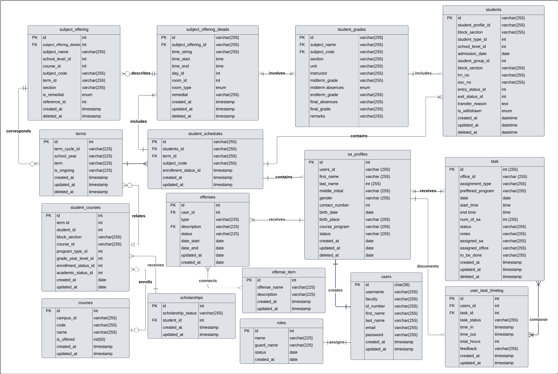

|  |  |  |  |  |  |  |  |  |
| --- | --- | --- | --- | --- | --- | --- | --- | --- |
| **TABLE NAME** | **ATTRIBUTE NAME** | **CONTENTS** | **TYPE** | **FORMAT** | **RANGE** | **REQUIRED** | **PK or FK** | **FK REFERENCED TABLE** |
| **users** | id | User ID | CHAR | Xxxxx | 36 | Yes | PK |  |
| username | Email of user | VARCHAR | [Xxxxxxx@apc.edu.ph](mailto:Xxxxxxx@apc.edu.ph) | 255 | Yes |  |  |
| Id_number | ID number of user | VARCHAR | 0123-012345 | 255 | Yes |  |  |
| first_name | First name of user | VARCHAR | Xxxxxx | 255 |  |  |  |
| Last_name | The last name of the user | VARCHAR | Xxxxxx | 255 |  |  |  |
| email | APC email of the user | VARCHAR | [Xxxxxxx@outlook.com](mailto:Xxxxxxx@outlook.com) | 255 |  |  |  |
| password | APC password of the user | VARCHAR | Xxxxxxx | 255 |  |  |  |
| Created_at | When is the account created | TIMESTAMP | YYYY-MM-DD HH:NN:SS |  |  |  |  |
| Updated_at | When is the account updated | TIMESTAMP | YYYY-MM-DD HH:NN:SS |  |  |  |  |
| **student_assistant** | id | Student Assistant user ID | VARCHAR |  | 255 | Yes | PK |  |
| Student_profiles_id | Student ID number | VARCHAR | 0123-012345 | 255 | Yes | FK | students |
| program_type | Student assistant program | VARCHAR | Xxxxxxx | 255 | Yes | FK | courses |
| Hours_rendered | Hours rendered by each SA | INT | 99 | 255 | Yes |  |  |
| Time_in | Student Assistant task time in | Timestamp | HH:MM:SS |  |  |  |  |
| Time_out | Student Assistant task time out | Timestamp | HH:MM:SS |  |  |  |  |
| **student_assistant_manager** | id | SA Manager user ID | INT | 99 | 255 | Yes | PK |  |
| Last_name | SA Manager’s last name | VARCHAR | Xxxxxxx | 255 | Yes |  |  |
| First_name | SA Manager’s first name | VARCHAR | Xxxxxxx | 255 | Yes |  |  |
| Middle_name | SA Manager’s middle name | VARCHAR | Xxxxxxx | 255 |  |  |  |
| **departments** | id | Requesting Office user ID | INT | 999 | 255 | Yes | PK |  |
| name | Requesting Office name | VARCHAR | Xxxxxxx | 255 |  |  |  |
| **tasks** | id | Table ID | VARCHAR | 999 | 255 | Yes | PK |  |
| office_id | Requesting Office user ID | VARCHAR | 999 | 255 | Yes | FK | Departments |
| assignment_type | Type of task:  - Voluntary  -Criteria-Based | VARCHAR | 999 | 255 | Yes |  |  |
| date | Task date | DATE | MMM-DD-YYYY |  | Yes |  |  |
| start_time | Start time of the task | TIME | 00:00:00 |  | Yes |  |  |
| end_time | End time of the task | TIME | 00:00:00 |  | Yes |  |  |
| Num_of_SA | Number of SA needed for the task | INT | 99 | 255 | Yes |  |  |
| Task_Program | Required program of SA | VARCHAR | Xxxxxxxxxxxxxx | 255 |  |  |  |
| status | Task status | VARCHAR | Xxxxxxx | 255 |  |  |  |
| notes | Requesting Office’s message or note for SA before doing the task | VARCHAR | Xxxxxxxxxxxxxx | 255 |  |  |  |
| assigned_sa | SAs assigned to the task | VARCHAR | Xxxxxx XxxxxxxXxxxxx | 255 | Yes |  |  |
| assigned_office | Assigned office that created the task | VARCHAR | Xxxxxxx | 255 | Yes |  |  |
| **feedback** | id | Feedback ID | INT | 999 | 255 | Yes | PK |  |
| Office_id | Requesting Office user ID | INT | 999 | 255 | Yes | FK | departments |
| Studentassistant_id | Student Assistant user ID | INT | 999 | 255 | Yes | FK | Student_assistant |
| Student_assistant_manager_id | SA Manager user ID | INT | 999 | 255 | Yes | FK | Student_assistant_manager |
| Feedback_text | Feedback of office to the assigned SA for that task | VARCHAR | Xxxxxxxxxxx | 255 | Yes |  |  |
| **Courses** | id | Unique ID for each course | INT | 999 | - | Yes | PK | - |
| Campus_id | Identifier for campus | VARCHAR | Xxxxxxx | 225 | Yes | FK | campus |
| code | Course code | VARCHAR | Xxxxxxx | 225 | Yes |  |  |
| name | Course name | VARCHAR | Xxxxxxxx | 225 | Yes |  |  |
| Is_offered | Indicates if course is offered (0 or 1) | INT | 0 or 1 | 1 | Yes |  |  |
| Created_at | Record creation timestamp | TIMESTAMP | YYYY-MM-DD HH:MM | - | Yes |  |  |
| Updated_at | Record update timestamp | TIMESTAMP | YYYY-MM-DD HH:MM | - | Yes |  |  |
| **offenses** | id | Unique offense ID | INT | 999 | - | Yes | PK |  |
| user_id | Identifier of the user associated with the offense | INT | 999 | - | Yes | FK | users |
| type | |  | | --- | | Type of offense |  |  | | --- | |  | | VARCHAR | Xxxxxxx | 225 | Yes |  |  |
| description | Description of the offense | VARCHAR | Xxxxxxxxx | 225 | Yes |  |  |
| status | Status of the offense | VARCHAR | Xxxxxxxx | 225 | Yes |  |  |
| date_start | Offense start date | DATE | |  | | --- | | YYYY-MM-DD |  |  | | --- | |  | | - | Yes |  |  |
| date_end | Offense end date | DATE | |  | | --- | | YYYY-MM-DD |  |  | | --- | |  | | - | Yes |  |  |
| created_at | Record creation timestamp | TIMESTAMP | |  | | --- | | YYYY-MM-DD HH:MM |  |  | | --- | |  | | - | Yes |  |  |
| updated_at | Record update timestamp | TIMESTAMP | |  | | --- | | YYYY-MM-DD HH:MM |  |  | | --- | |  | | - | Yes |  |  |
| **offense_items** | id | Unique ID for offense item | INT | 999 | - | Yes | PK |  |
| |  | | --- | | offense_name |  |  | | --- | |  | | Name of the offense item | VARCHAR | Xxxxxxxxx | 225 | Yes |  |  |
| description | Description of the offense item | VARCHAR | Xxxxxxx | 225 | Yes |  |  |
| created_at | |  | | --- | |  |  |  | | --- | | Record creation timestamp | | TIMESTAMP | |  | | --- | | YYYY-MM-DD HH:MM |  |  | | --- | |  | | - | Yes |  |  |
| updated_at | Record update timestamp | TIMESTAMP | |  | | --- | | YYYY-MM-DD HH:MM |  |  | | --- | |  | | - | Yes |  |  |
| **roles** | id | |  | | --- | | Unique role ID |  |  | | --- | |  | | INT | 999 | - | Yes | PK |  |
| name | Name of the role | VARCHAR | Xxxxxx | 225 | Yes |  |  |
| guard_name | Guard name for role | VARCHAR | Xxxxxxxx | 225 | Yes |  |  |
| status | |  | | --- | | Role status |  |  | | --- | |  | | VARCHAR | Xxxxxxx | - | Yes |  |  |
| created_at | Record creation date | TIMESTAMP | |  | | --- | | YYYY-MM-DD |  |  | | --- | |  | | - | Yes |  |  |
| **sa_profiles** | id | Unique SA profile ID | INT | 999 |  | Yes | PK |  |
| user_id | User ID | VARCHAR | Xxxxxxxx | 225 | Yes | FK | users |
| first_name | First name of the SA | VARCHAR | Xxxxxxxx | 225 | Yes |  |  |
| last_name | Last name of the SA | VARCHAR | Xxxxxxxx | 225 | Yes |  |  |
| middle_initial | Middle initial of the SA | VARCHAR | X | 225 | No |  |  |
| gender | |  | | --- | | Gender of the SA |  |  | | --- | |  | | VARCHAR | Xxxxxxxx | 225 | Yes |  |  |
| contact_number | Contact number of the SA | INT | - | - | No |  |  |
| birth_date | Birth date of the SA | DATE | |  | | --- | | YYYY-MM-DD |  |  | | --- | |  | | - | Yes |  |  |
| birth_place | Birthplace of the SA | VARCHAR | Xxxxxxxx | 225 | Yes |  |  |
| course_program | SA's course program | VARCHAR | Xxxxxxxx | 225 | Yes |  |  |
| status | Profile status | VARCHAR | Xxxxxxxx | 225 | Yes |  |  |
| created_at | Record creation timestamp | DATE | |  | | --- | | YYYY-MM-DD HH:MM |  |  | | --- | |  | | - | Yes |  |  |
| updated_at | Record update timestamp | DATE | YYYY-MM-DD HH:MM | - | No |  |  |
| deleted_at | Record deletion timestamp | DATE | |  | | --- | | YYYY-MM-DD HH:MM |  |  | | --- | |  | | - | No |  |  |
| **Scholarships** | id | Unique scholarship ID | INT | 999 | - | YES | PK | - |
| student_id | |  | | --- | | ID of the student |  |  | | --- | |  | | INT | 999 | - | YES | FK | students |
| scholarship_status | |  | | --- | | Status of scholarship |  |  | | --- | |  | | VARCHAR | Xxxxxxxx | 225 | YES | - | - |
| created_at | |  | | --- | | Record creation timestamp |  |  | | --- | |  | | TIMESTAMP | |  | | --- | | YYYY-MM-DD HH:MM |  |  | | --- | |  | | - | YES | - | - |
| updated_at | Record update timestamp | TIMESTAMP | |  | | --- | | YYYY-MM-DD HH:MM |  |  | | --- | |  | | - | YES | - | - |
| **student_courses** | id | Unique student course ID | INT | 999 | - | YES | FK | - |
| term_id | Term ID | INT | 999 | - | YES | FK | terms |
| student_id | |  | | --- | | Student ID |  |  | | --- | |  | | INT | 999 | - | YES | FK | students |
| block_section | |  | | --- | | Block section |  |  | | --- | |  | | VARCHAR | Xxxxxxxx | 225 |  |  |  |
| **student_grades** | id | Unique student grade ID | VARCHAR | Xxxxxxxx | 225 | Yes | PK |  |
| subject_name | Name of subject | VARCHAR | Xxxxxxxx | 225 | Yes | FK |  |
| subject_code | Subject code | VARCHAR | XXXXXX | 225 | Yes | FK | Subject_offering_details |
| unit | Unit per subject | VARCHAR | Xxxxxxxx | 225 | Yes |  |  |
| instructor | Name of instructor per subject | VARCHAR | Xxxxxxxx | 225 | Yes |  |  |
| midterm_grade | Midterm grades | VARCHAR | Xx | 225 | Yes |  |  |
| midterm_absences | Absences during midterms | Enum | 99 | 225 | Yes |  |  |
| endterm_grades | Endterm grades | VARCHAR | Xx | 225 | Yes |  |  |
| final_absences | Absences during finals | VARCHAR | Xx | 225 | Yes |  |  |
| final_grade | Grades during finals | VARCHAR | Xx | 225 | Yes |  |  |
| remarks | Comments/remarks of instructor | VARCHAR | Xx | 225 |  |  |  |
| **student_schedules** | id | Unique id | VARCHAR | Xxx | 225 | Yes | PK |  |
| student_id | Student table id | VARCHAR | Xxx | 225 | Yes | FK | students |
| term_id | Term_table_id | VARCHAR | Xxx | 225 | Yes | FK | term |
| subject_code | Subject code | VARCHAR | XXXXXXX | 225 | Yes |  |  |
| enrollment_status_id | Unique id of enrollment status | timestamp | YYYY-MM-DD HH:MM |  | Yes |  |  |
| create_at | When the input is created | Timestamp | YYYY-MM-DD HH:MM |  | Yes |  |  |
| updated_at | When the input is updated | timestamp | YYYY-MM-DD HH:MM |  | Yes |  |  |
| **tasks** | id | Table ID | VARCHAR | 999 | 255 | Yes | PK |  |
| office_id | Requesting Office user ID | VARCHAR | 999 | 255 | Yes |  |  |
| assignment_type | Type of task:   - Voluntary  -Criteria-Based | VARCHAR | 999 | 255 | Yes |  |  |
| date | Task date | DATE | MMM-DD-YYYY |  | Yes |  |  |
| start_time | Start time of the task | TIMESTAMP | YYYY-MM-DD HH:MM |  | Yes |  |  |
| end_time | End time of the task | TIMEStamp | YYYY-MM-DD HH:MM |  | Yes |  |  |
| Num_of_SA | Number of SA needed for the task | INT | 99 | 255 | Yes |  |  |
| Task_Program | Required program of SA | VARCHAR | Xxxxxxxxxxxxxx | 255 |  |  |  |
| status | Task status | VARCHAR | Xxxxxxx | 255 |  |  |  |
| notes | Requesting Office’s message or note for SA before doing the task | VARCHAR | Xxxxxxxxxxxxxx | 255 |  |  |  |
|  |  |  |  |  |  |  |  |
| assigned_sa | SAs assigned to the task | VARCHAR | Xxxxxx XxxxxxxXxxxxx | 255 | Yes |  |  |
| assigned_office | Assigned office that created the task | VARCHAR | Xxxxxxx | 255 | Yes |  |  |
| **terms** | Id | Table id | Int | 99 |  | Yes | PK |  |
| school_year | School year | VARCHAR | Xxxxxxxx | 225 | Yes |  |  |
| term | Term in a school year | VARCHAR | Xxxxxxxx | 225 | Yes |  |  |
| is_ongoing | Status of term | VARCHAR | Xxxxxxxx | 225 | Yes |  |  |
| created_at | When is the table created | Timestamp | YYYY-MM-DD HH:MM |  | Yes |  |  |
| updated_at | When is the table updated | Timestamp | YYYY-MM-DD HH:MM |  | Yes |  |  |
| deleted_at | when the table is deleted | timestamp | YYYY-MM-DD HH:MM |  | Yes |  |  |
| user_tasks_timelog | id | Table id | Int | 99 |  | Yes | PK |  |
| users_id | Users table id | Int | 99 |  | Yes | FK | users |
| task_id | Task table id | int | 99 |  | Yes | FK | task |
| task_status | Status of task | timestamp | YYYY-MM-DD HH:MM |  | Yes |  |  |
| time_in | Time in of SA | timestamp | YYYY-MM-DD HH:MM |  | Yes |  |  |
| time_out | Time out of SA | timestamp | YYYY-MM-DD HH:MM |  | Yes |  |  |
| total_hours | Total hours rendered of SA for that task | int | 999 |  | Yes |  |  |
| feedback | Feedback from office | varchar | Xxxxxxxxx | 255 | Yes |  |  |
| created_at | When is the input created | Timestamp | YYYY-MM-DD HH:MM |  | Yes |  |  |
| updated_at | When is the input updated | timestamp | YYYY-MM-DD HH:MM |  | Yes |  |  |

Appendix B - Group Log

|  |  |  |  |
| --- | --- | --- | --- |
| **Meeting Minutes** | | | |
| Date and Time | September 6, 2024, 9:30 PM | Location | MS Teams |
| Attendees | * Nathan Rameses Balois * Sayaka Aliyah Hernandez * Priam Japheth Jauod * Gianna Cristina Reyes * Alelie Yvonne Tayco * John Michael Gonzales | | |
| Meeting Agenda | Check user stories, create product backlogs, update use case diagram | | |
| Discussion | Add Guidance Office in user stories, product backlogs, use case diagram | | |
| Action Items | Consultation with Sir Sean | | |

|  |  |  |  |
| --- | --- | --- | --- |
| **Meeting Minutes** | | | |
| Date and Time | September 9, 2024, 9:30 PM | Location | MS Teams |
| Attendees | * Nathan Rameses Balois * Sayaka Aliyah Hernandez * Priam Japheth Jauod * Gianna Cristina Reyes * Alelie Yvonne Tayco * John Michael Gonzales | | |
| Meeting Agenda | * Assign members for UCFD, ERD, SRS * Start wireframe | | |
| Discussion | Software Requirements Specification Document Parts:  1.1 - 1.3 - Nathan Rameses L Balois 1.4 - 1.6 - John Michael Gonzales 2.1 - 2.2 - Priam Japheth Jauod 2.3 - 3.1 - Hernandez 3.2 - 3.3 - Gianna Cristina S Reyes 4 - Alelie Yvonne Tayco  Discussion regarding DO's response | | |
| Action Items | * *S*RS Individual parts | | |

|  |  |  |  |
| --- | --- | --- | --- |
| **Meeting Minutes** | | | |
| Date and Time | October 15, 2024, 9:30 PM | Location | MS Teams |
| Attendees | * Nathan Rameses Balois * Sayaka Aliyah Hernandez * Priam Japheth Jauod * Gianna Cristina Reyes * Alelie Yvonne Tayco * John Michael Gonzales | | |
| Meeting Agenda | System Updates  Individual parts Update | | |
| Discussion | Move deadline for Test Plan Document  Check logic of scholarship module  List of errors:  Probation and revoked scholarship table (Guidance and DO side)  Add major offense form | | |
| Action Items | * Update sharepoint project task list * Continue individual parts * Schedule consultation for adviser and client next week | | |

Appendix C – Test Plan/Test Cases

|  |  |
| --- | --- |
| **Test Plan** | [Test Plan Outline.docx](https://asiapacificcollege.sharepoint.com/:w:/s/DIVAlopers/Ecz9W5uG8AFBm8iYTKJqpIABJXExB5QqVo4ppx7xoecM6A?e=5PNn2k) |
| **Test Cases** | [Test-case-template-xls.xlsx](https://asiapacificcollege.sharepoint.com/:x:/s/DIVAlopers/ESeGpA_BlMpHuhkA2776i0YBbIxLsJrXKKlzSlFDD0F0Gw?e=MPxBfL) |